0

SCOUTABOUT FIRE PLAN
2001 Bayliner 3788

Skipper: Rick Nolte
- Cell: 206-965-0357
- Email: rick.nolte@gmail.com
1st Mate: Kim Nolte
- Cell: 206-965-0550
- Email: skimhikes@yahoo.com
Home Port: Elliot Bay Marina
Fire Extinguisher Locations:
- Flybridge
- Main Salon (2)
- Master Stateroom
- Engine Room
CO, Smoke Alarms: CO alarm in galley, smoke alarm in hallway, CO alarm in lazarette.
Fire Exit Locations: Master stateroom hatch, rear salon exit, flybridge stairs and access areas.
Life Vest Location: Flybridge stowage bin (Qty-12).
Electrical Power Shutoff: Electrical control panel, port side main salon (110 & 12). Battery shutoff under floor panel inside rear salon exit.

FIRE EXTINGUISHER LOCATIONS
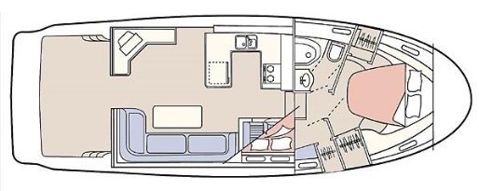
NOTE: One additional fire extinguisher on Flybridge below console
X000
X
X
X
